## **In Lab Task 2**

## **Proteus Schematic:**

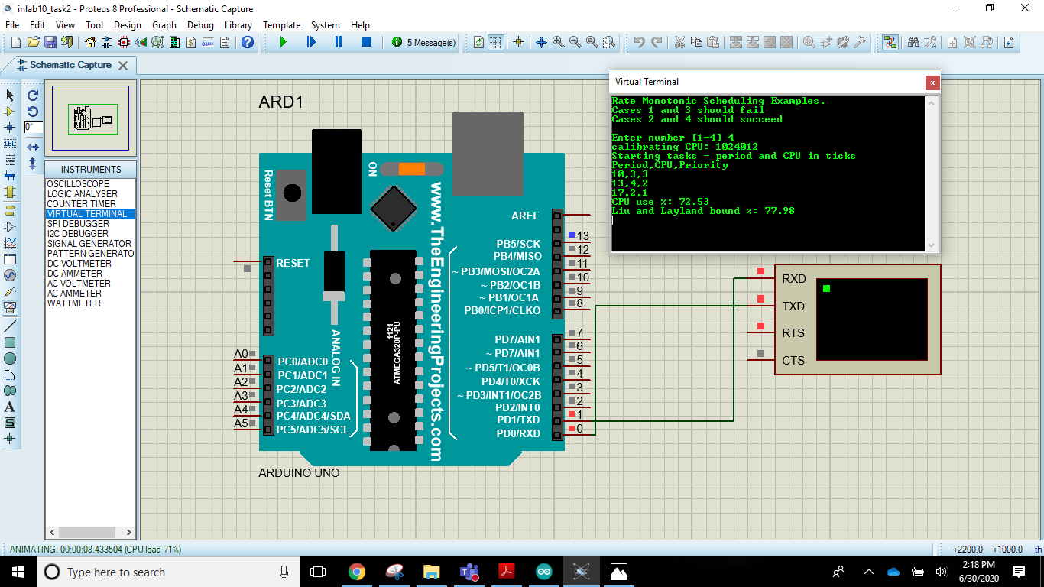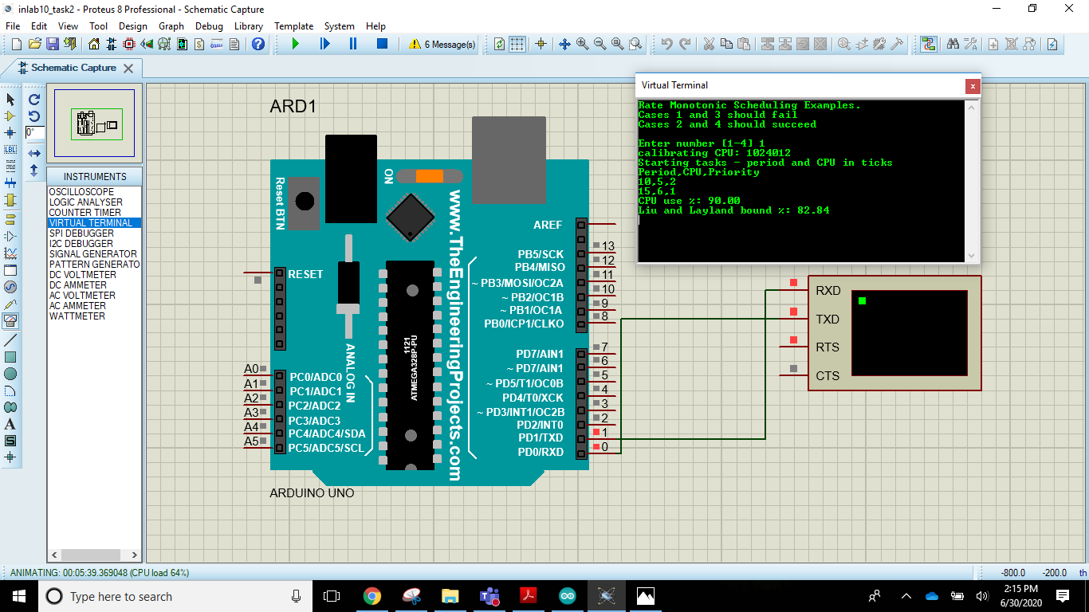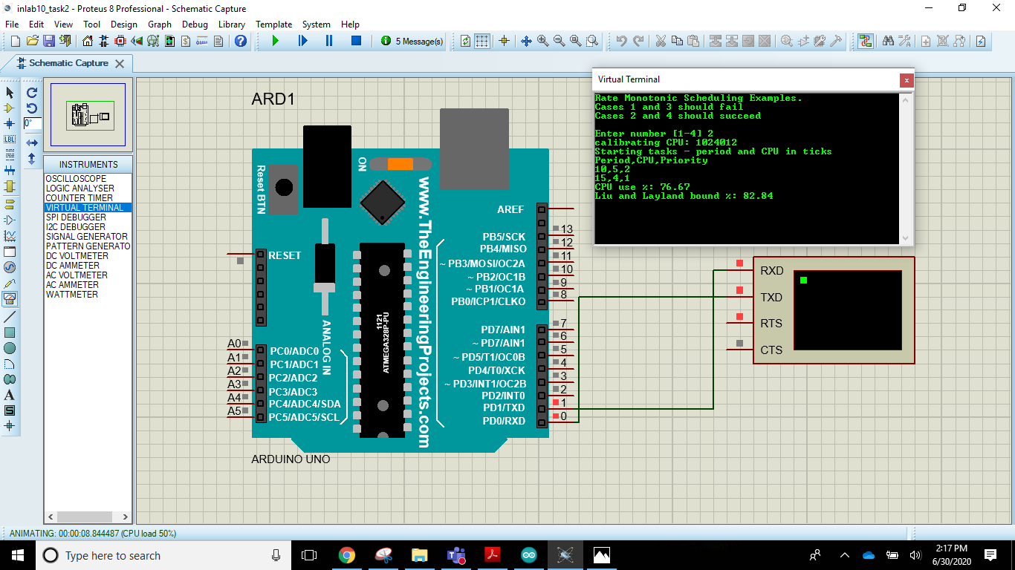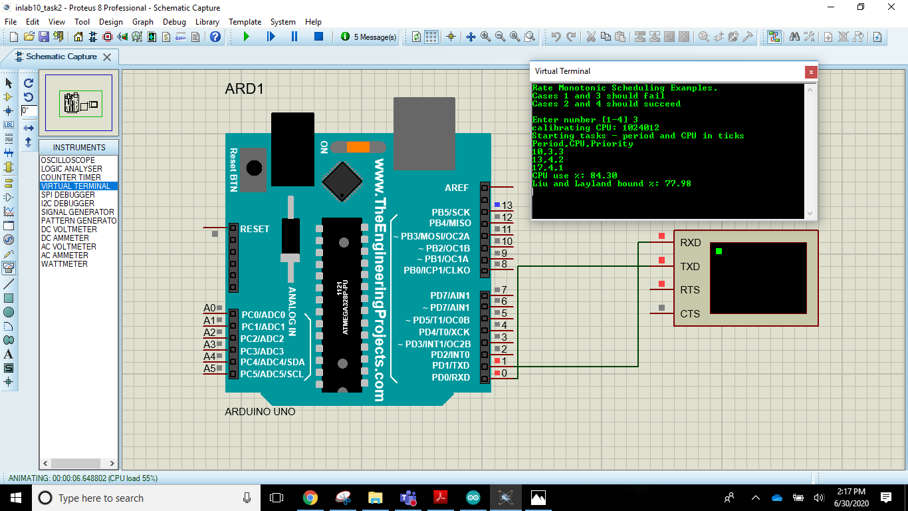

## **Arduino IDE Code:**

|  |
| --- |
| // Illustration of Rate Monotonic Scheduling from Liu and Layland paper  //  // Rate Monotonic Scheduling for a set of repeating tasks gives higher  // priority to a task with a smaller period.  //  // Theorem Liu and Layland 1973. Given a preemptive, fixed priority scheduler  // and a finite set of repeating tasks T = {T1; T2; ...; Tn} with associated  // periods {p1; p2 ...; pn} and no precedence constraints, if any priority  // assignment yields a feasible schedule, then the rate monotonic  // priority assignment yields a feasible schedule.  //  // Liu and Layland also derived a bound on CPU utilization that guarantees  // there will be a feasible Rate Monotonic Schedule when a set of n tasks  // have CPU utilization less than the bound.  //  // The Liu Layland bound = 100*n*(2^(1/n) - 1) in percent. For large n  // this approaches ln(2) or 69.3%. The extra CPU time can be used by  // lower priority tasks that do not have hard deadlines.  //  // Note that it may be possible to run a given set of tasks with higher CPU  // utilization, depending on task parameters. The Liu Layland bound works  // for every set of tasks independent of task parameters.  //  #include <Arduino_FreeRTOS.h>  #include <semphr.h>  //------------------------------------------------------------------------------  struct task_t {  uint16_t period;  uint16_t cpu;  uint16_t priority;  };  task_t tasks1[] = {{10, 5, 2}, {15, 6, 1}};  task_t tasks2[] = {{10, 5, 2}, {15, 4, 1}};  task_t tasks3[] = {{10, 3, 3}, {13, 4, 2}, {17, 4, 1}};  task_t tasks4[] = {{10, 3, 3}, {13, 4, 2}, {17, 2, 1}};  task_t* taskList[] = {tasks1, tasks2, tasks3, tasks4};  int taskCount[] = {2, 2, 3, 3};  //------------------------------------------------------------------------------  // override IDE definition to prevent errors  void printTask(task_t* task);  void done(const char* msg, task_t* task, TickType_t now);  //------------------------------------------------------------------------------  // Liu Layland bound = 100*n*(2^(1/n) - 1) in percent  float LiuLayland[] = {100, 82.84271247, 77.97631497, 75.682846, 74.3491775};  //------------------------------------------------------------------------------  #ifdef __AVR__  const unsigned int CAL_GUESS = 3000;  const float TICK_USEC = 1024;  #else // __AVR__  const unsigned int CAL_GUESS = 17000;  const float TICK_USEC = 1000;  #endif // __AVR__  // dummy CPU utilization functions  static unsigned int cal = CAL_GUESS;  void burnCPU(uint16_t ticks) {  while (ticks--) {  for (unsigned int i = 0; i < cal; i++) {  asm("nop");  }  }  }  void calibrate() {  uint32_t t = micros();  burnCPU(1000);  t = micros() - t;  cal = (TICK_USEC*1000*cal)/t;  }  //------------------------------------------------------------------------------  // print helpers  void printTask(task_t* task) {  Serial.print(task->period);  Serial.write(',');  Serial.print(task->cpu);  Serial.write(',');  Serial.println(task->priority);  }  void done(const char* msg, task_t* task, TickType_t now) {  vTaskSuspendAll();  Serial.println(msg);  Serial.print("Tick: ");  Serial.println(now);  Serial.print("Task: ");  printTask(task);  while(1);  }  //------------------------------------------------------------------------------  // start tasks at 1000 ticks  TickType_t startTime = 1000;  // test runs for 3000 ticks  TickType_t finishTime = 4000;  // task code  void task(void* arg) {  uint16_t period = ((task_t*)arg)->period;  uint16_t cpu = ((task_t*)arg)->cpu;  // simulate last wake time  TickType_t lastWakeTime = startTime - period;  while (xTaskGetTickCount() < lastWakeTime) vTaskDelay(1);  while (1) {  vTaskDelayUntil(&lastWakeTime, period);  burnCPU(cpu);  // check of failure or success  TickType_t now = xTaskGetTickCount();  if (now >= finishTime) {  done("Success", (task_t*)arg, now);  }  if (now >= (lastWakeTime + period)) {  done("Missed Deadline", (task_t*)arg, now);  }  }  }  //------------------------------------------------------------------------------  void setup() {  float cpuUse = 0; // total cpu utilization for set of tasks  int c; // Serial input  int n; // number of tasks to run  task_t* tasks; // list of tasks to run  portBASE_TYPE s; // task create status  Serial.begin(9600);  while(!Serial) {}  Serial.println("Rate Monotonic Scheduling Examples.");  Serial.println("Cases 1 and 3 should fail");  Serial.println("Cases 2 and 4 should succeed");  Serial.println();  // get input  while (1) {  while (Serial.read() >= 0) {}  Serial.print("Enter number [1-4] ");  while ((c = Serial.read()) < 0) {}  Serial.println((char)c);  if (c < '1' || c > '4') {  Serial.println("Invalid input");  continue;  }  c -= '1';  tasks = taskList[c];  n = taskCount[c];  break;  }  Serial.print("calibrating CPU: ");  // insure no interrupts from Serial  Serial.flush();  delay(100);  calibrate();  uint32_t t = micros();  burnCPU(1000);  Serial.println(micros() -t);  Serial.println("Starting tasks - period and CPU in ticks");  Serial.println("Period,CPU,Priority");  for (int i = 0; i < n; i++) {  printTask(&tasks[i]);  cpuUse += tasks[i].cpu/(float)tasks[i].period;  s = xTaskCreate(task, NULL, 200, (void*)&tasks[i], tasks[i].priority, NULL);  if (s != pdPASS) {  Serial.println("task create failed");  while(1);  }  }  Serial.print("CPU use %: ");  Serial.println(cpuUse*100);  Serial.print("Liu and Layland bound %: ");  Serial.println(LiuLayland[n - 1]);  // start tasks  vTaskStartScheduler();  Serial.println("Scheduler failed");  while(1);  }  //------------------------------------------------------------------------------  void loop() {  // Not used - idle loop has a very small, configMINIMAL_STACK_SIZE, stack  // loop must never block  } |